Math 1303-04
A
Test #2 – Fall 2011
Name:
Show all your work, unsupported answers will receive no credit. Use correct mathematical notation at all times, points will be deducted for incorrect notation. Write your answers to word problems in complete sentence and include appropriate units. BOX YOUR ANSWERS.

1. Determine which of the following relationships represent functions. Circle them.
x
x
a) b)

c) d)

2. Simplify the difference quotient 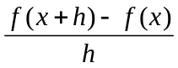for the function 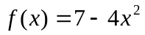

3. A manufacturer of office furniture determines that the cost per desk C of producing x hundred desks is given by the function 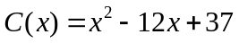, where C is in hundreds of dollars and 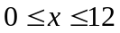
- Draw a careful graph of the function C(x). Determine the coordinates of the vertex and the x- and y-intercepts (if any). Show all your work, a graph from the calculator will receive NO CREDIT.
b) How many desks need to be manufactured to make the cost per desk minimum? What is the minimum cost per desk? Answer in complete sentence and include units
x

4. For the function 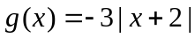 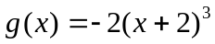
- Determine the elementary function f(x) and draw the graph of each transformation. Mark three points on each graph. Describe in words each of the transformations that were performed on f(x) to get to the final function. Order of operations MUST be followed to get full credit.
- Determine the domain and the range of the resulting function
x
x
x

Domain: Range:

5. Consider the polynomial function 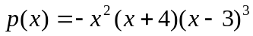
a) Write the leading term and determine the end behavior of the function (use arrow notation)
b) Find the zeros of the polynomial and determine if the graph crosses or bounces at each x-int.
c) Find the y- intercept
d) Sketch a graph of the function.
BOX YOUR ANSWERS
x

6. For the rational function 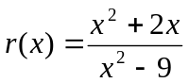
a) Determine the domain and find all the horizontal asymptotes (describe the end behavior using arrow notation), vertical asymptotes, and holes (if any). SHOW YOUR WORK AND BOX YOUR ANSWERS
b) Find the x- and y-intercepts
x
c) Graph the function (Use test points if needed)

7. Complete the square to analyze the quadratic function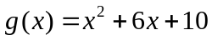. Determine the coordinates of the vertex, the x- and y- intercepts, and draw the graph of the function. You must show ALL your work. GRAPHS FROM CALCULATORS WILL RECEIVE NO CREDIT.
x

Extra Credit

Simplify the difference quotient for 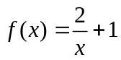

On my honor, I verify that I have neither received any help nor given any information about this exam.

_______________________________

